Geology 101 Pima Community College Name_________________________
Date ______________

Chapter 16 Lab: Measuring Earthquakes

This lab exercise involves using the following information and graphs to determine the following attributes of an actual earthquake that occurred in the Missouri region around 3:46 AM on June 19, 1987:

- Distance from the earthquake
- Earthquake magnitude
- Earthquake location

Distance from an Earthquake
Using the figure below, determine the distance from the earthquake to a seismograph station that received the P and S waves 5.0 minutes apart: ______________ km.

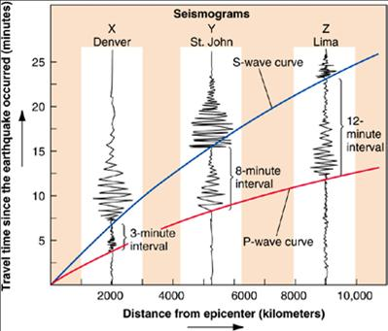

Earthquake Magnitude
Using the following nomogram, determine the earthquake magnitude for the three earthquakes listed below (A, B, and C).

Earthquake | S-P Difference in  Arrival Times | Amplitude of Deflection | Earthquake Magnitude
A | 8 seconds | 20 mm
B | 8 seconds | 0.2 mm
C | 6 seconds | 10 mm

Determining the Location of an Actual Earthquake
The middle Mississippi Valley is one of the areas of the United States that frequently experience earthquakes. Three earthquakes took place near New Madrid, Missouri in 1811-1812 which are thought by seismologists to have been the strongest in recorded history for North America. These earthquakes rang church bells in Boston, Massachusetts and briefly reversed the course of the Mississippi River! Statistical studies indicate that there is a 50:50 chance that a magnitude 6.5 earthquake will occur in this region in our lifetime.

The three seismograms below record a magnitude 3.0 earthquake that occurred in the Missouri region around 3:46 AM on June 19, 1987. Use these seismograms and the arrival time graph below it to complete the table on the hand in exercise. This information was provided by Professor Brian J. Mitchell of Saint Louis University.

Use the following three seismograms for a magnitude 3.0 earthquake that occurred in the Missouri region around 3:46 AM on June 19, 1987. Use these seismograms and the arrival time graph below it to complete the following table. This information was provided by Professor Brian J. Mitchell of Saint Louis University.

Arrival Time Graph
Location | P arrival time  (hours:minutes:seconds.tenths of seconds) | S arrival time  (hr:min:sec.1/10 sec) | Difference in P & S arrivals (seconds.tenths of seconds) | Distance in kilometers
LTN
GOIL
POW
Use the distances from the Arrival Time Graph above with following map figure below to determine the location of the 1987 earthquake. The figure on the following page is a map of the New Madrid seismic zone, showing three of the seismograph stations in the region: Powhatan, Arkansas (POW); Lennox, Tennessee (LTN); and Rosebud, Illinois (GOIL). Map of the New Madrid seismic zone showing three of the many seismograph stations in the region. Degrees north latitude and degrees west longitude are shown along the margins. Subdivisions of degrees are in tenths of a degree rather than in minutes.

The location of the 1987 earthquake is ____________ latitude, _______________ longitude.

